Roger Brown , Moonrise Consulting
roger@moonriseconsulting.com, @rwbrown

Mark Levison, Agile Pain Relief Consulting
mark@agilepainrelief.com, @mlevison

Continuous Creativity for Agile Teams
Agile 2010 - Orlando, August 12, 2010
What is Creativity?

Myths of Creativity
- Only some people are creative
- Creative people work alone
- Creative people are born that way
- The two hemispheres of our brains do different kinds of thinking
- People are predominantly right-brained (creative) or left-brained (logical)
- We use only 10% of our brain
A creative idea is novel, relevant and spontaneous (Amabile, 1983)
Creativity helps with
- Problem solving
- Refinement of product and process
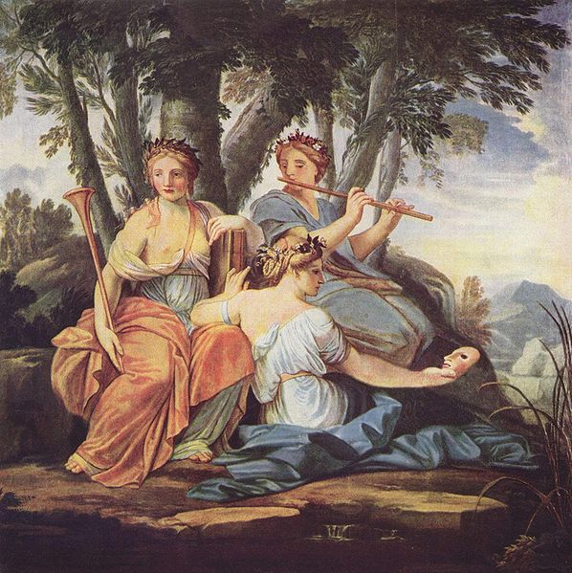
- Invention and innovation
Trying hard to be creative does not really work well because we overuse the wrong part of our brains. Can creativity be learned? Or is it more effective to create the right conditions for creativity?
Where Does Creativity Come From?
Creativity does not come from the places we have previously assumed: the Muses, genetics, school, high IQ. It comes from inner processing when conditions are right.
We use our whole brain, all of the time. There are some differences between the two hemispheres that result in some specialization, but both are involved in most of our higher-level mental processing.
The human brain has 3 main parts: the reptilian complex or old brain takes care of the autonomic nervous system that works to keep us alive. The limbic system or mid brain, inherited from our mammalian ancestry, manages our emotional state. The neocortex or new brain manages higher functions including language, speech, music, reasoning and conscious thinking.
Most of our thought process happens subconsciously where we have vastly larger and faster resources.

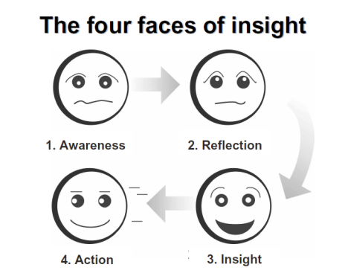
Working memory is limited in capacity and processing is slow due to complexity and energy demand of the neocortex. Long term memory is vastly larger and information is compressed and coded, allowing for faster access and searching.
The ARIA model from David Rock is a neuroscience-based model of creative thought.
- Awareness of a conflict between what we observe and what we already know
- Reflection on the conflict to find a way to reconcile it with what we know
- Insight into a resolution that builds a new neural map
- Action based on the insight, fueled by energy from the insight
Electrical changes are simultaneous with these steps. Reflection is characterized by slow-moving alpha waves. Insight gives off faster gamma waves.

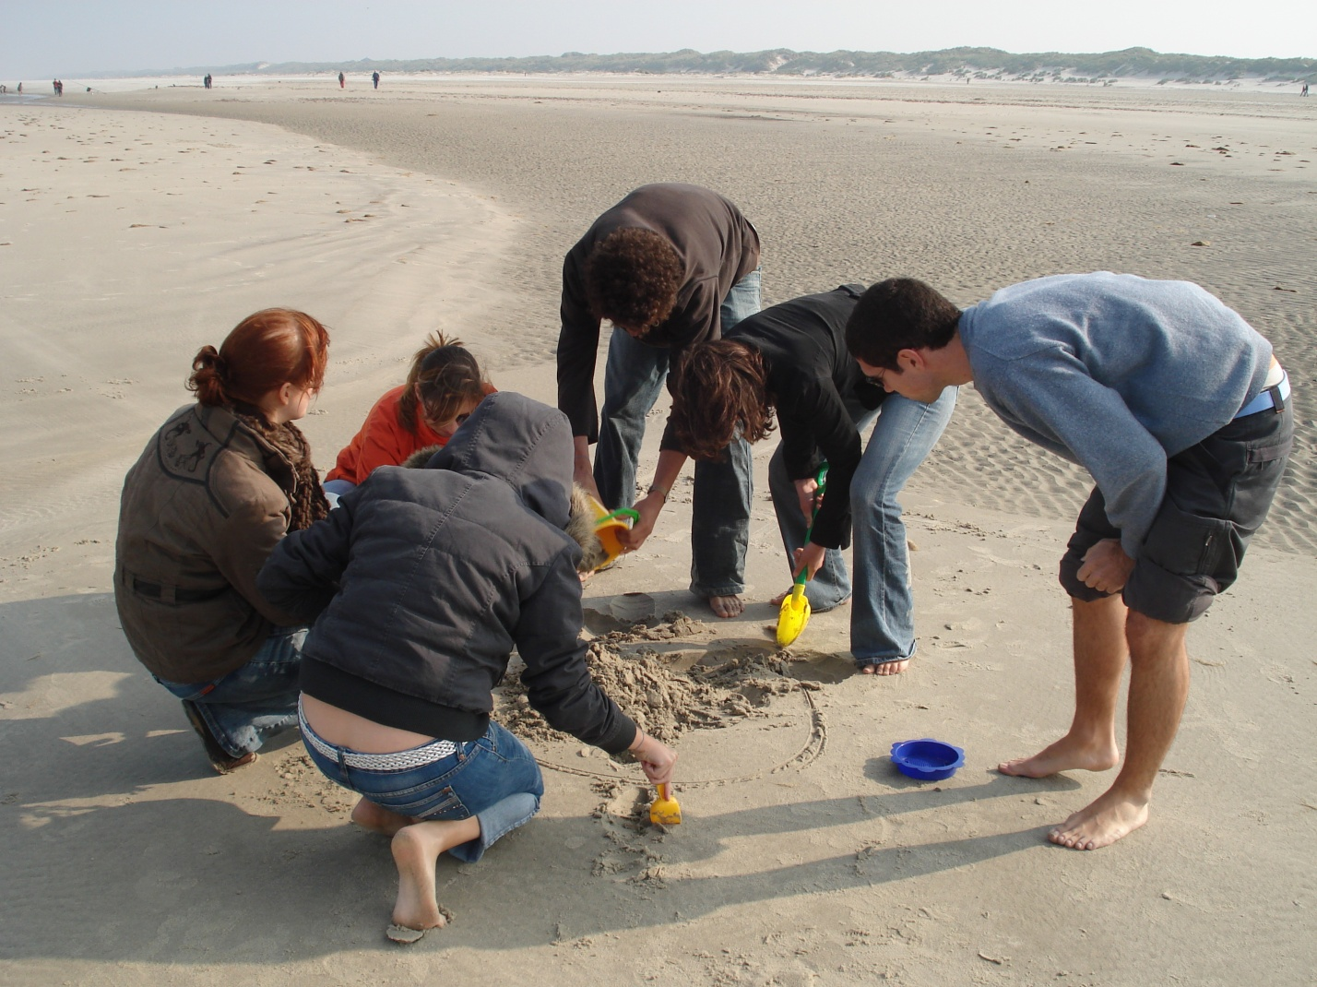
Group Creativity
Group creativity is an outcome of healthy collaboration. Some famous collaborations from the past include: NASA during the Apllo 13 crisis, J. R. R. Tolkien and the Inklings writers group, the Beatles and the founders of Apple Computer. There are many stories of individual genius and innovation that were actually serial collaborations. Some examples are Morse Code and the Theory of Evolution.
Many things can block creativity in a group including individual and group elements. These include:
- Too much detail in goal
- Too open-ended a target
- Command and control
- Noisy, stressed mind
- Yes, but… conversation stoppers
How to Nurture Group Creativity
Basics
- Providing an emotionally safe environment
- Reinforcing intrinsic motivators (autonomy, mastery, purpose) and a sense of progress
- Appreciating that a small amount of positive stress (eustress) is useful
Additional Creativity Tools
- Align to Common Goal
- Prepare
  - Relax, Warm up, ask questions, remember a similar experience
- Simple Factors
  - Encourage members to “Be creative!”, use physical objects, draw pictures
- Check Assumptions
  - For any that are not apparent or any that are not actually there
- Make it safe to fail
  - And learn from our experiments
- Quiet Mind
  - To allow for subconscious processing
- Appropriate Brainstorming
  - For the right kinds of questions and then use known patterns
- Expand Your Universe
  - Include outsiders, examine failures of new information, remove predictability
- Many Perspectives
  - There are some great tools for getting groups past the obvious and familiar into new points of view. Some we know of are:
    - Innovation Games ™ www.innovationgames.com
    - Edward de Bono’s Six Hats technique www.debonogroup.com
    - Agile Games discussion group www.agilegames.org
Group Flow
Flow for individuals is a state of maximum productivity when skills and interest are well matched to a particular challenge.
Group Flow can occur when these conditions are present:
- Group goal – we are all in this together
- Deep listening – Listening without speaking, absorbing what is being said
- Complete concentration – ability to focus on the work at hand, stay in context as long as it is productive
- Autonomy – being empowered to make your own decisions as a group and as a member of the group
- Blending egos – appreciating that everyone has something to contribute and the whole is greater than the sum of the parts
- Equal participation – all ideas are welcome, no one stands apart?
- Familiarity and continuity – it takes time for a team to gel. Don’t waste that investment
- Constant communication - …
- Moving forward
- Embracing failure
References
- Amabile, T. M. "The Social Psychology of Creativity: A Componential Conceptualization." Journal of Personality and Social Psychology 45 (1983)
- David Rock, Your Brain at Work
- Keith Sawyer, Group Genius
- Mihaly Csikszentmihalyi , Flow: The Psychology of Peak Performance
- Carl Zimmer, “The Wandering Mind”, Discover Magazine July/Aug 2009
- Gregory Berns, “Neuroscience Sheds New Light on Creativity”
http://www.fastcompany.com/magazine/129/rewiring-the-creative-mind.html
- Jonah Lehrer, “The Eureka Hunt”, New Yorker Magazine, July 28, 2008

